DEEP LEARNING

ICP-3

ASHISH MOTANAM GURUNADHAM

TEAM ID-14

CLASS ID-20

Vocabulary size = 5000

Window size = 150

Learning rate =0.01

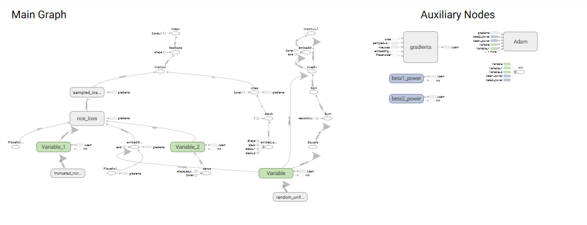

Vocabulary size = 20000

Window size = 100

Learning rate =0.02

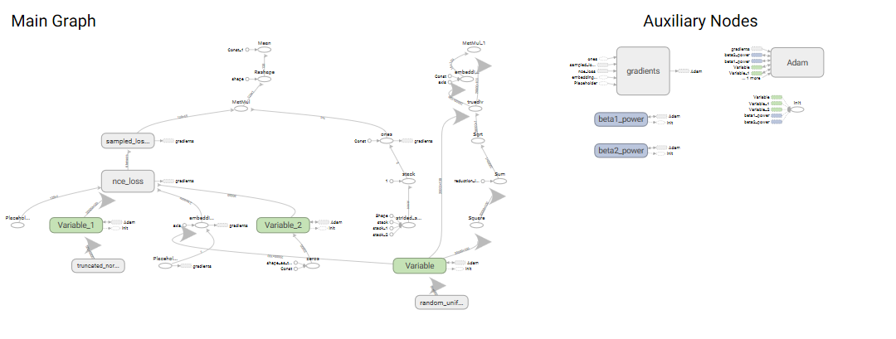

Vocabulary size = 50000

Window size = 150

Learning rate =0.05

